- Change it to “Participant Control” DONE
- Sorry - I just realized we should include a leaderboard. DONE- added Top 3 Teams revealing Leaderboard on Facilitator tab
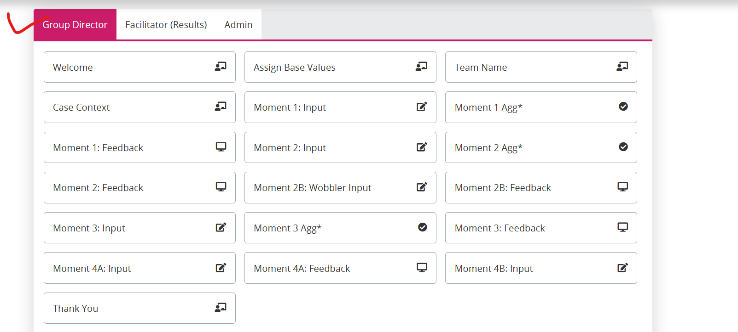

Add an icon for Data export.Done

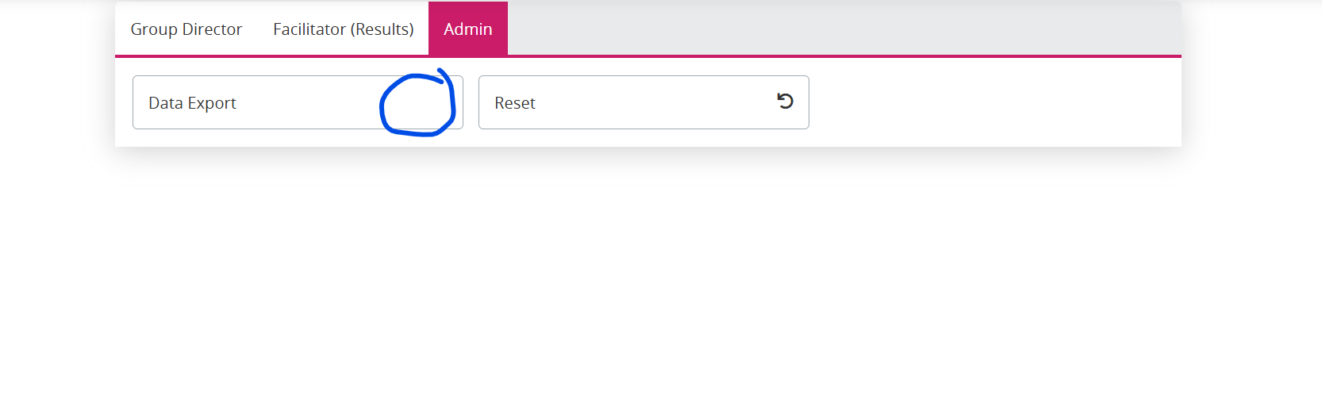

- For M1-M4, I think it should say “Moment #: <moment header>” DONE
- For both options of M4, header should just say “Moment 4: <header>”… No 4a / 4b DONE
- For Moment 2b (the wobbler), we can avoid adding “Moment #”… Only header text should suffice. DONE

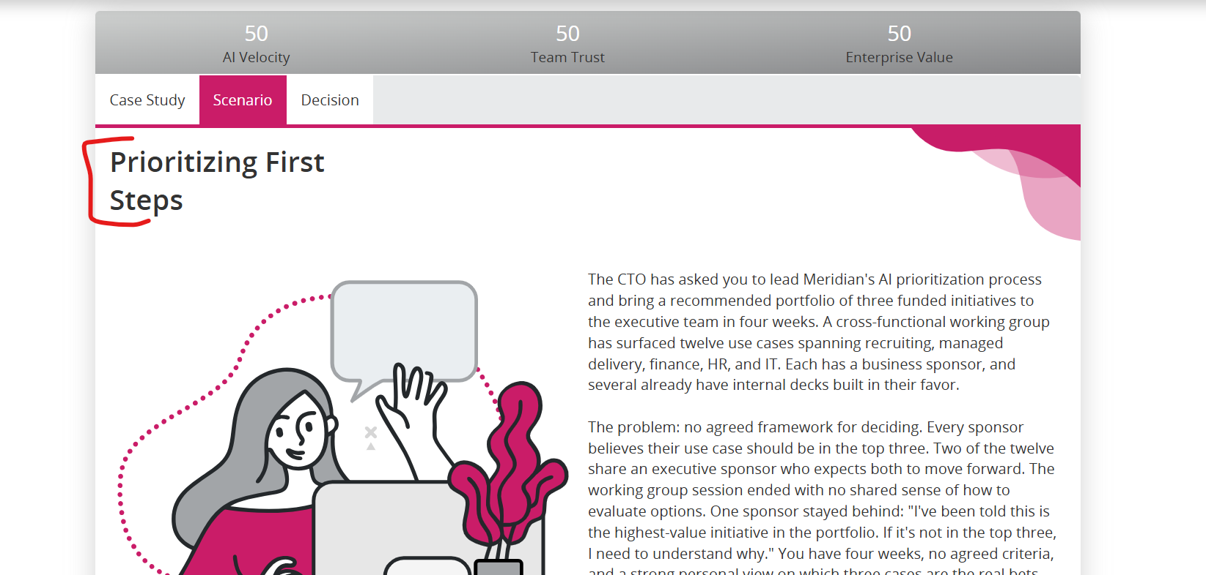

<applicable to all moments with SS>
Update instructions to read “Choose one of the options given below, and tap Submit.” DONE

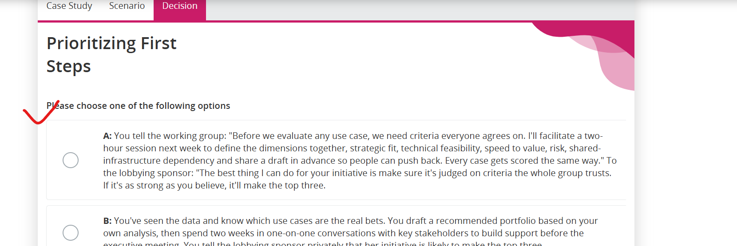

<applicable to all moments>
- It may get fixed after styling – right border is missing. DONE
- Add the sub-description text that is the question statement from the scenario - What do you do? DONE

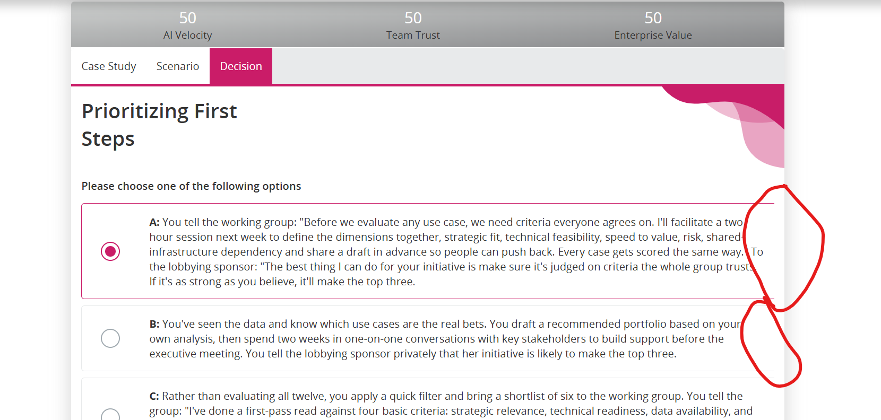

<applicable to all moments>
- Keep this in standard format... option text followed by the feedback DONE
- Add Case Study and Scenario tabs on feedback screens as well. DONE

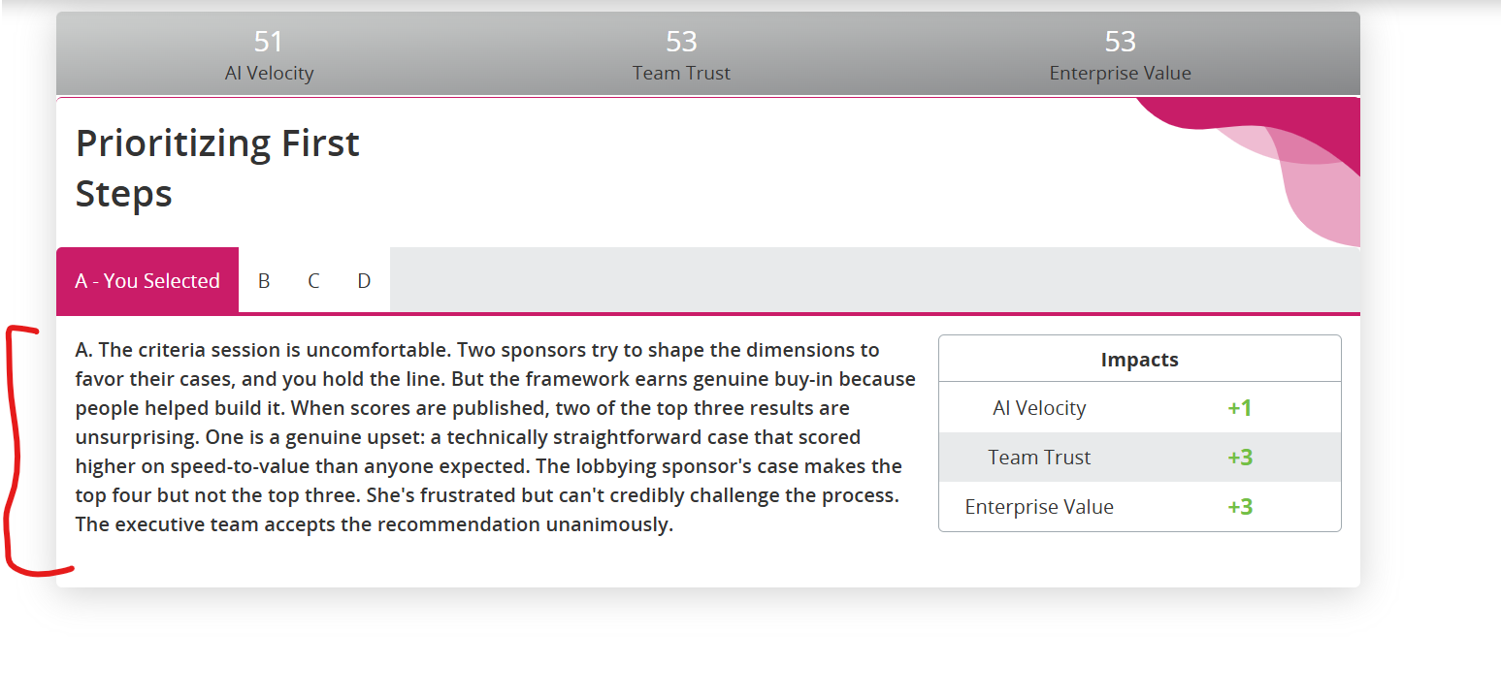

M2- There are double quotes here. DONE

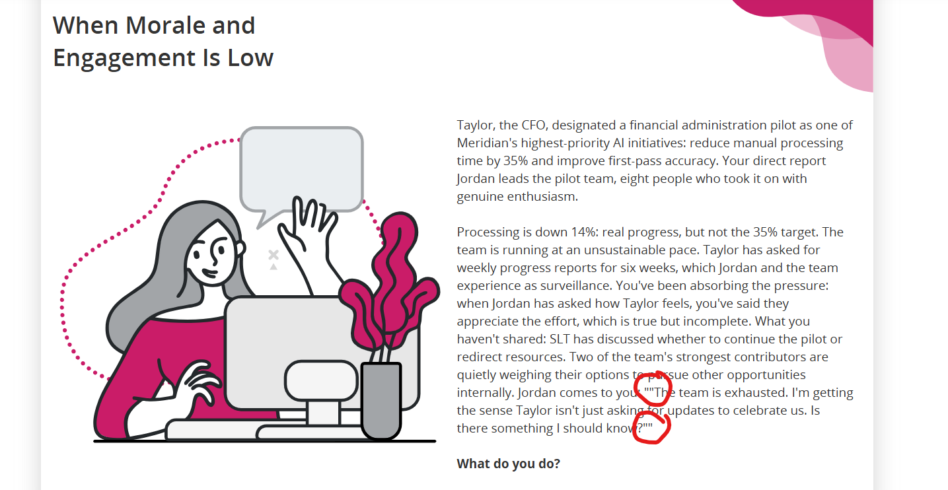

Keep the use of tick consistent – either have it on all or do not have it on any screen.
Currently team name screen does not have it.
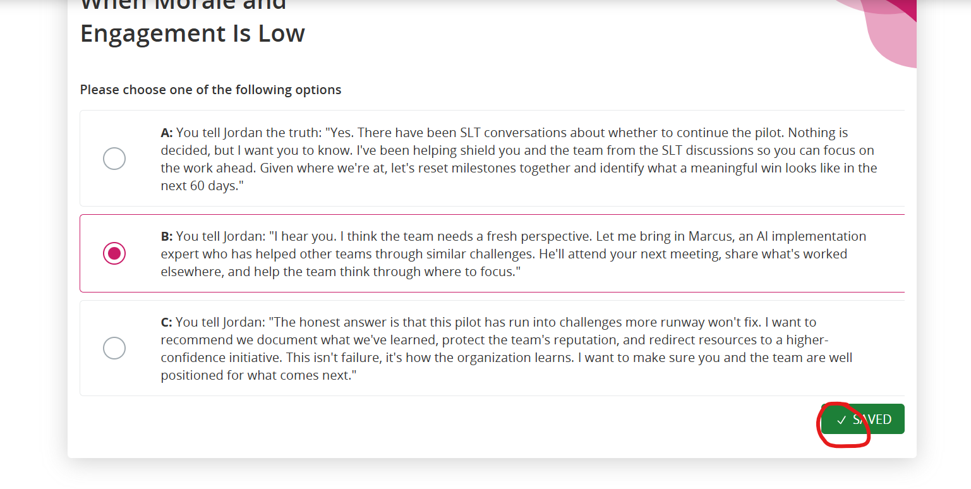

Wobbler:
- Add “New Information” as the header DONE
- Double quotes DONE
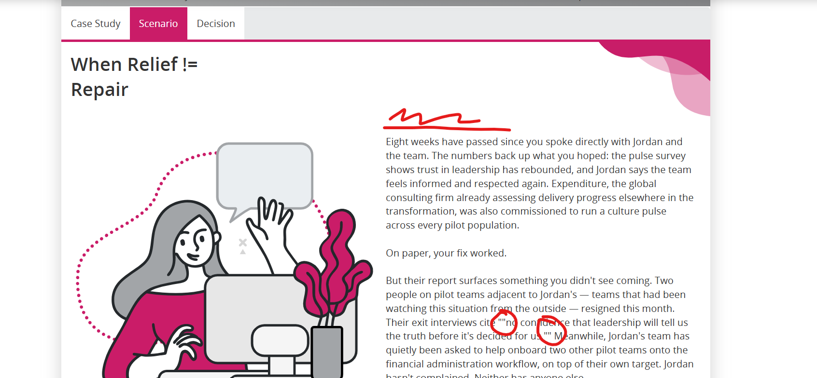

Can these numbers be centrally aligned? They currently look top-aligned. DONE

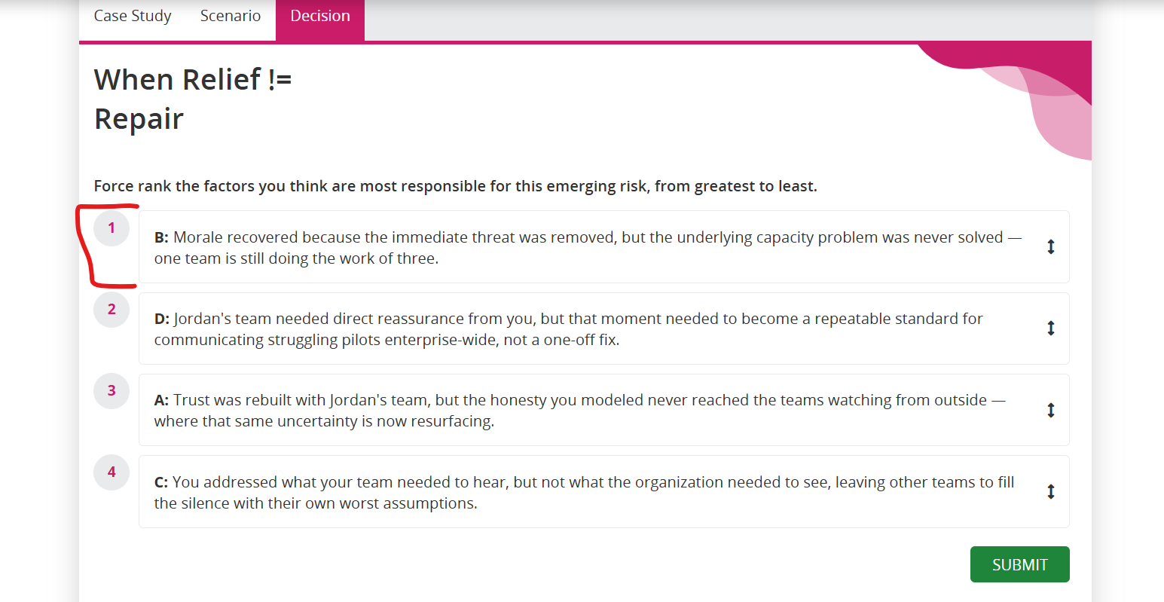

For ranking activity, can we show the following text on the right instead of a specific sequence? DONE
If not, we should probably remove this screen since per the given text both A and C can be in 2nd position. So, no fixed “correct sequence” per se.

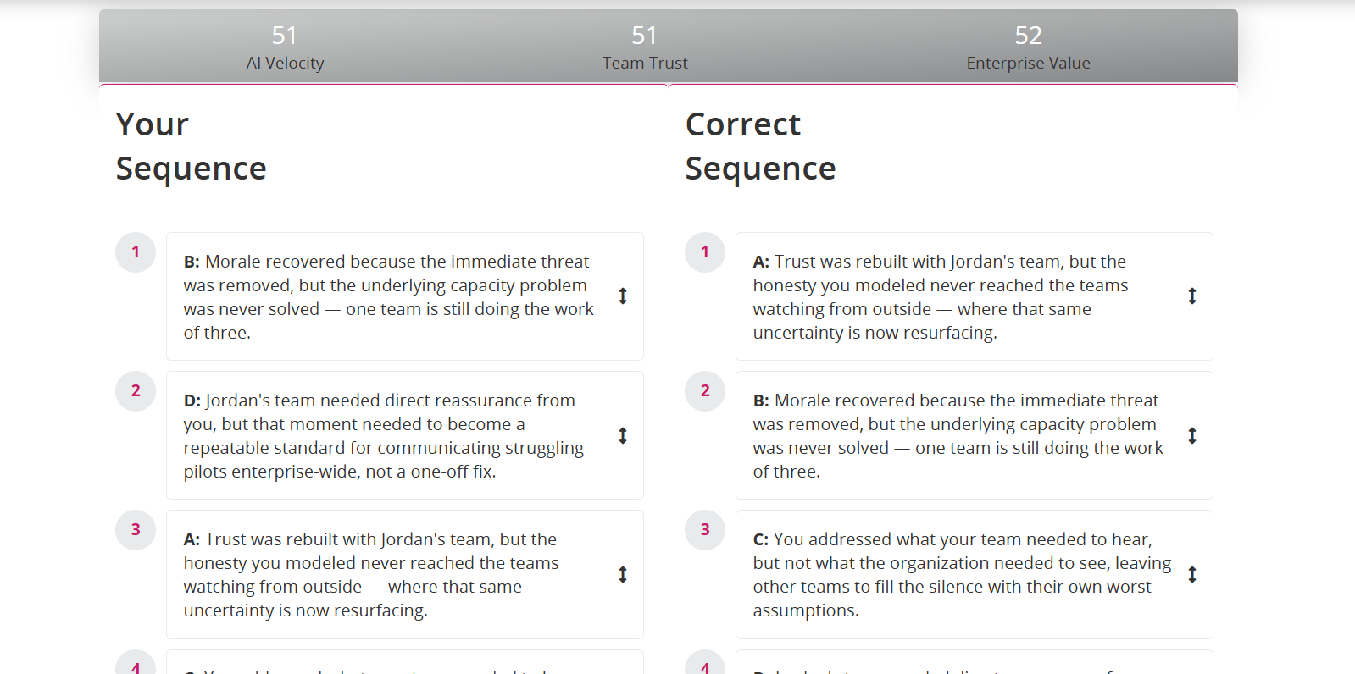

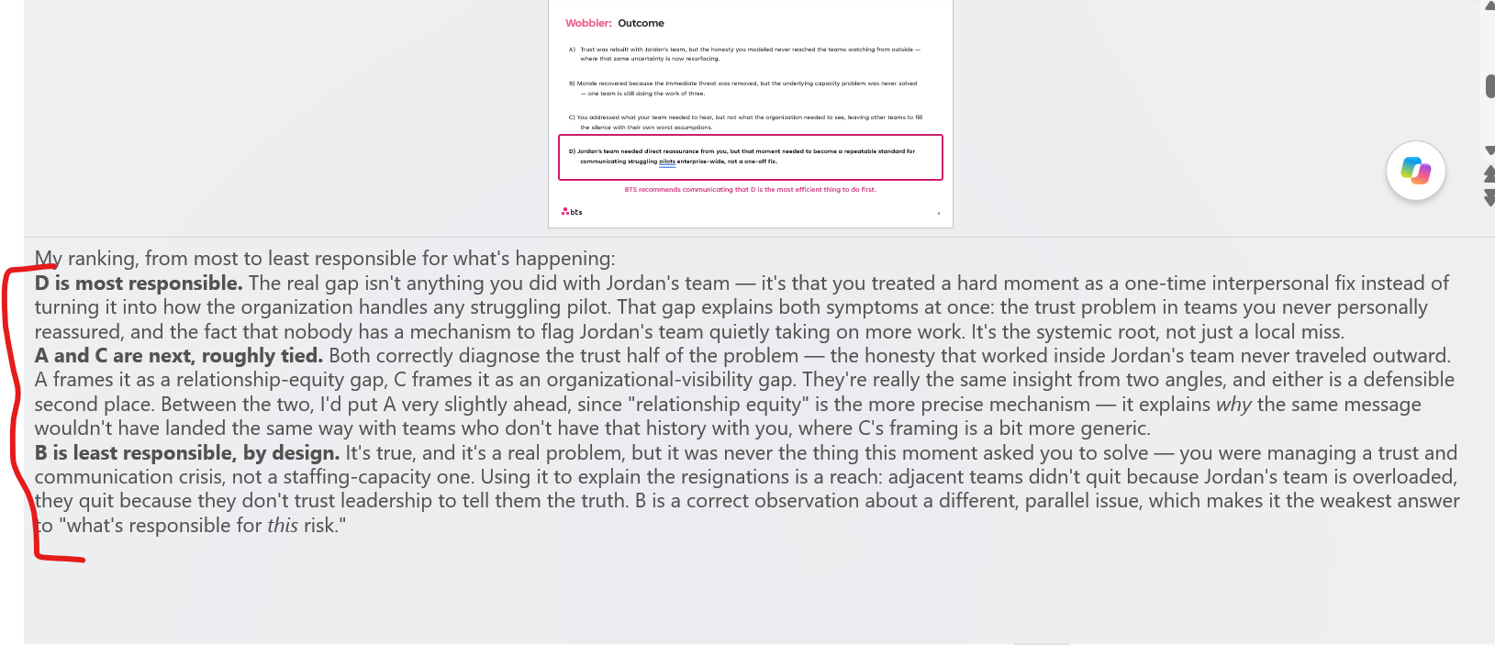

M3: Double quotes DONE

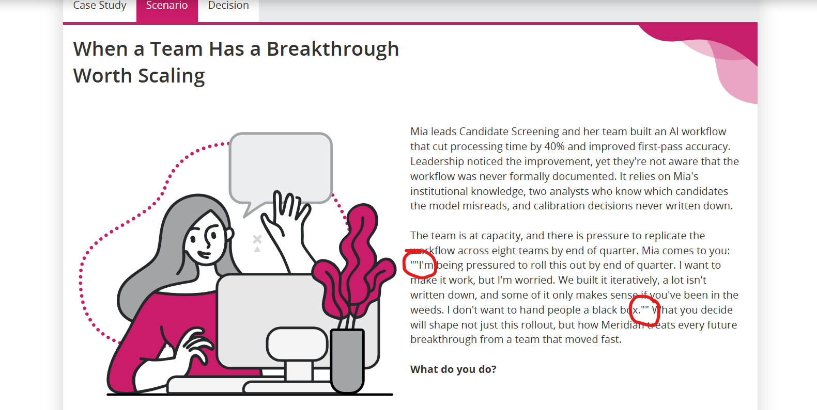

M3: Remove the accordions. DONE

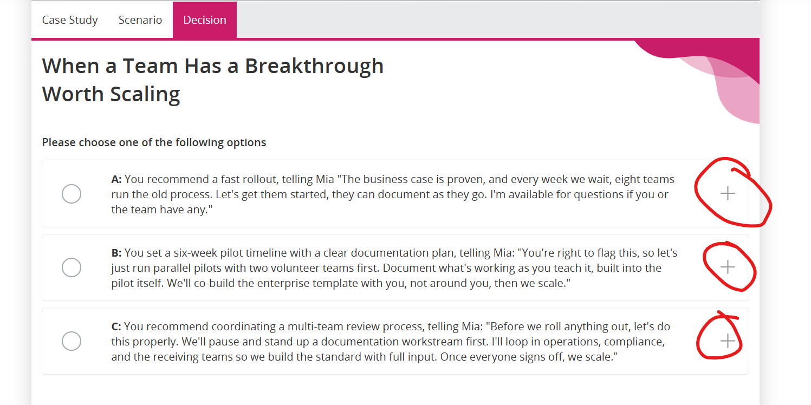

M4a and M4b: Double quotes DONE

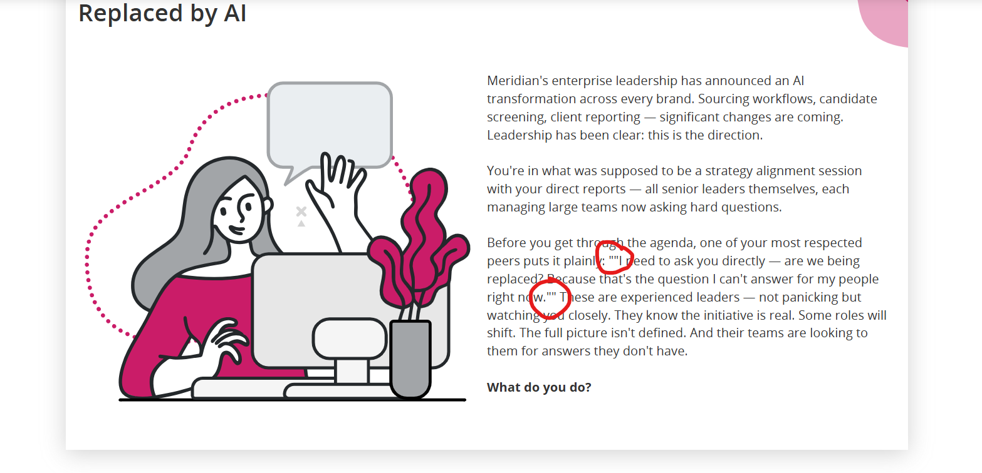

As we had discussed, please add the text input here itself. Giving a separate tab for a closed BS does not make much sense. DONE

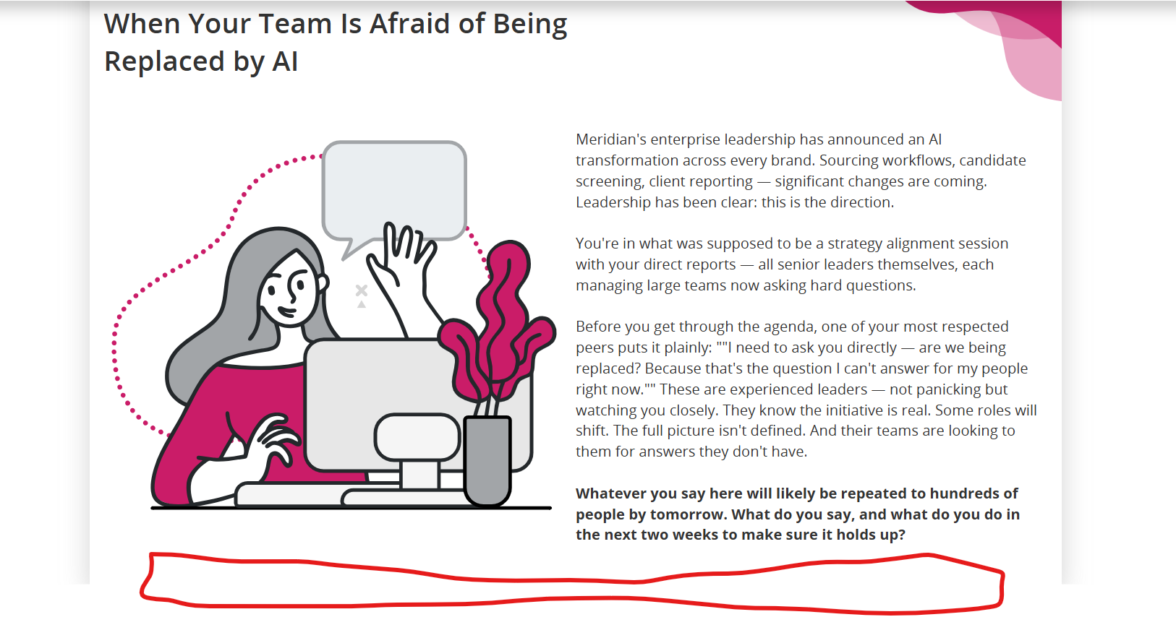

Make only the column header centrally aligned. DONE

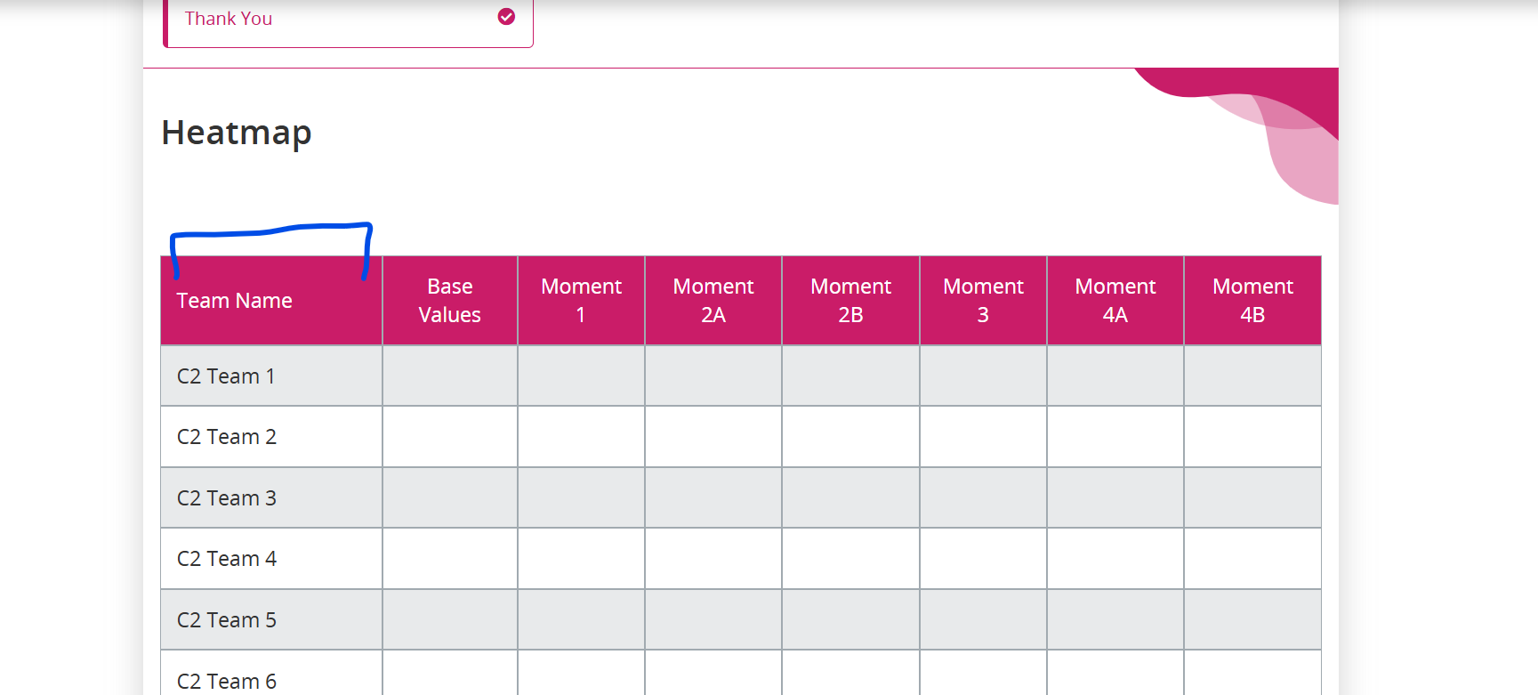

<applicable to all moments>
- Add “Moment #: ” DONE
- Add question statement here. DONE
- Add % DONE
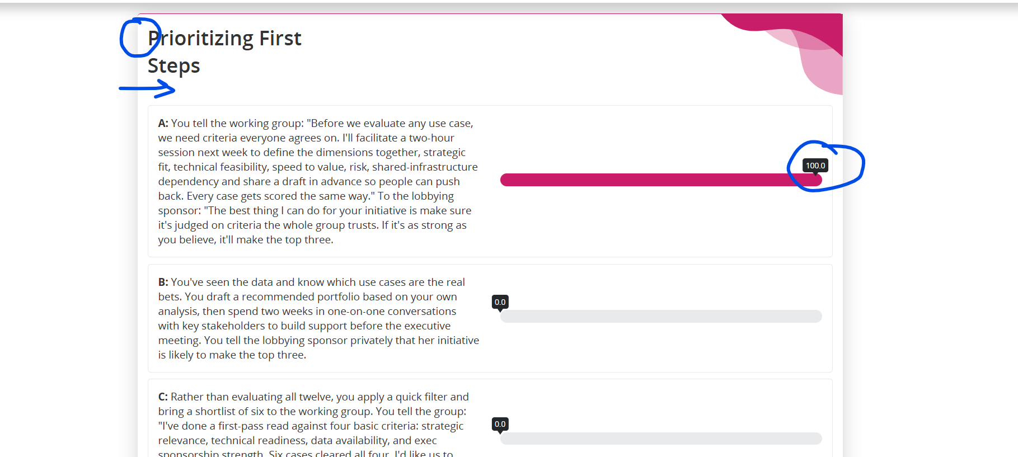

We somehow need to indicate that D is the most optimum choice – it needs to be visually appealing.
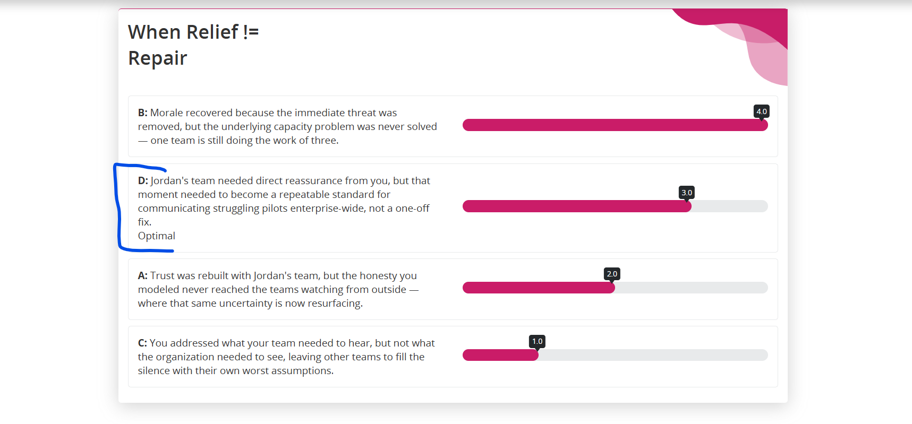

I understand styling is in progress, but we need to keep the use of header image consistent. DONE

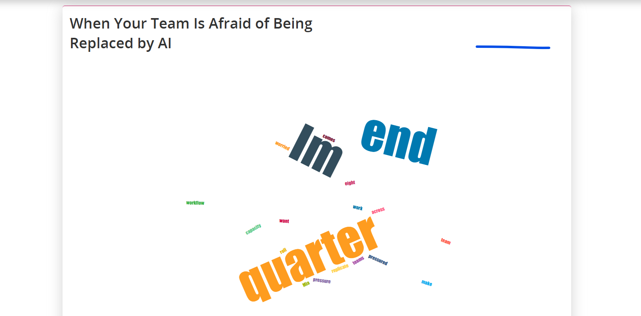

We don’t need these columns. DONE
Also, remove “Moment 2B submitted (111 = done)” column. DONE
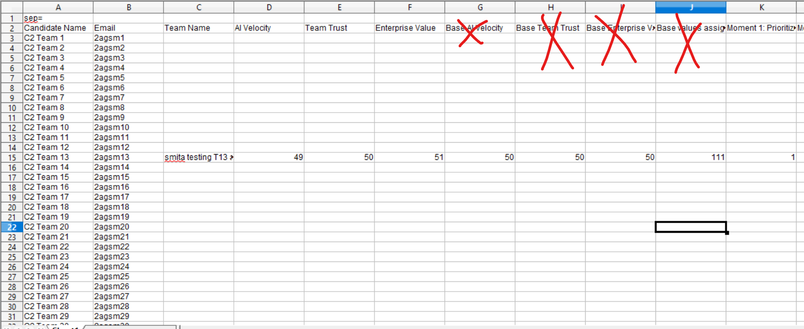

On reset, teams should go back to initial blank screen. DONE

